**Create a new xcode project**

1. Open **Xcode** then welcome screen window will appear.

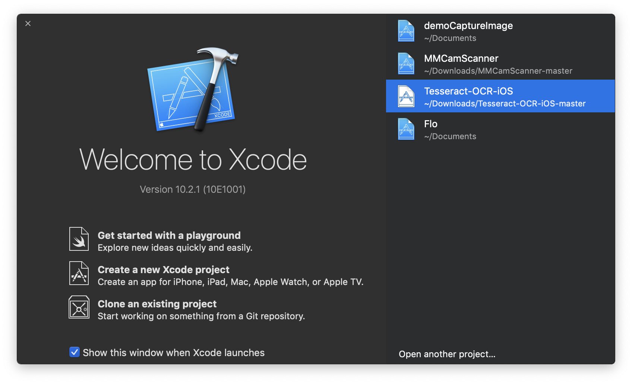

1. In the welcome screen window click “**Create a new Xcode project**”.

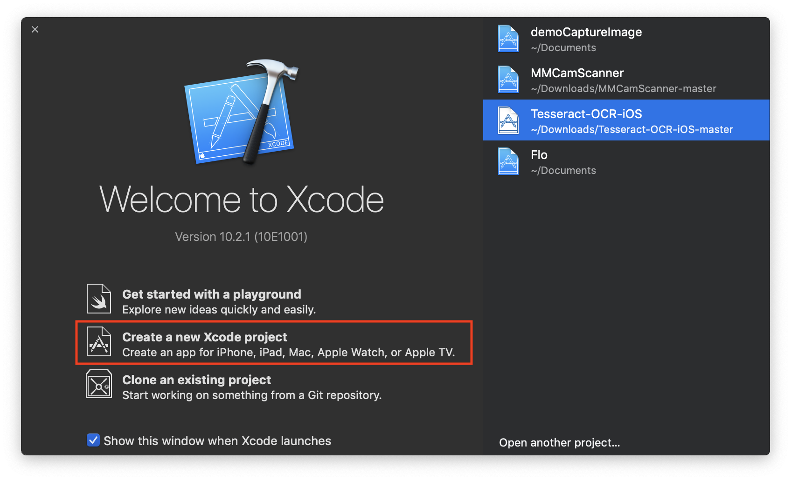

or choose **File > New > Project**.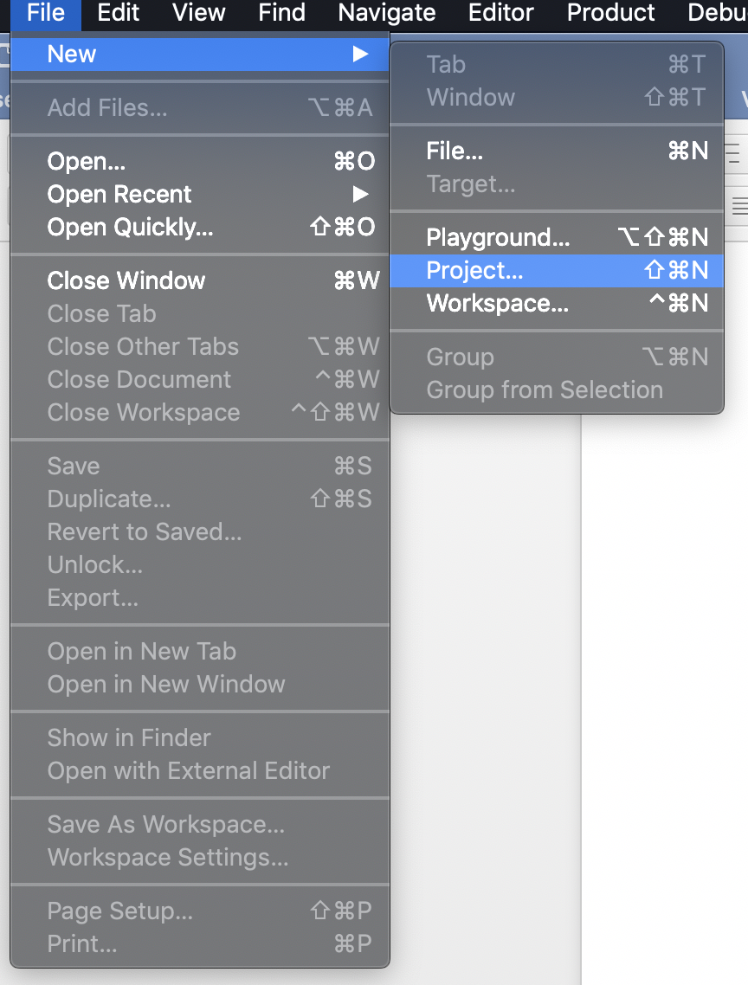

1. Select “**iOS**” at the top of dialog and in “**Application**” section choose “**Single View App**” then click “**Next**”.

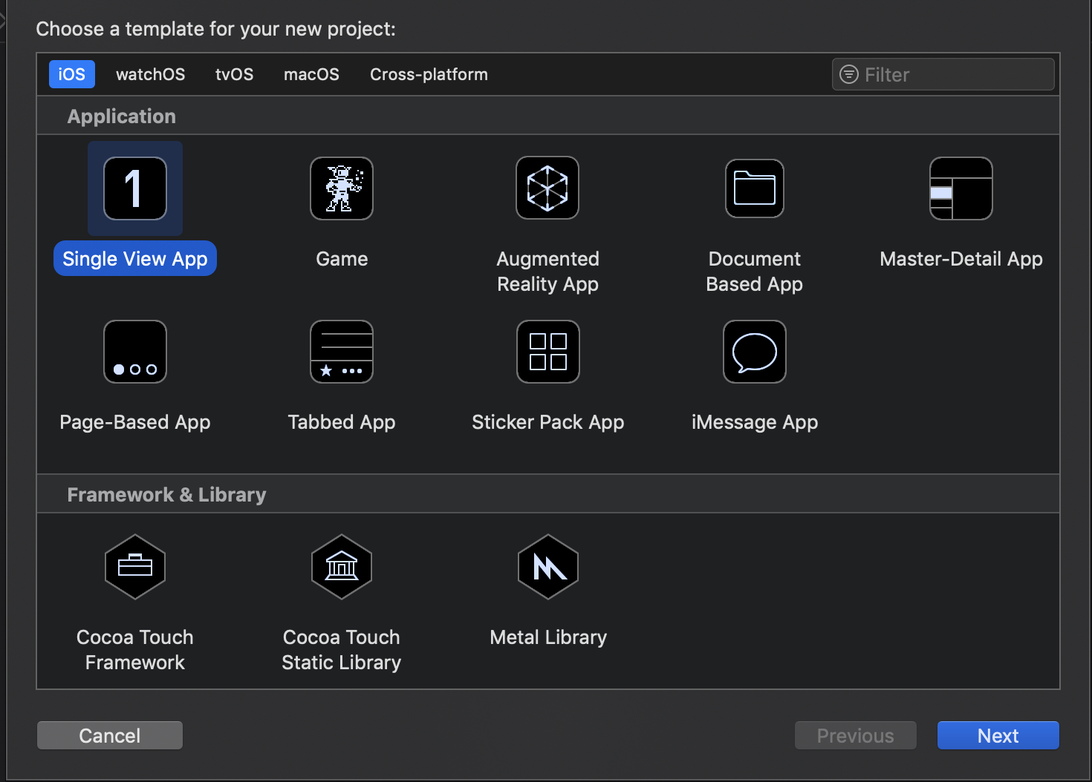

1. In the next window appear fill in by the following information:

* Product Name: “**demoCaptureImage**”
* Team: If this is not automatically fill in, set to none or leave as is.
* Organization Name: Your own name (Mine is **“phatnt”)**
* Organization Identifier: “**dev.rakumo**”
* Bundle Identifier: This value is automatically generated based on your product name and organization identifier.
* Language: Choose **“Swift**”
* Use Core Data: Unselect
* Include Unit Tests: Select (Optional)
* Include UI Tests: Select (Optional)

Then click “**Next”.**

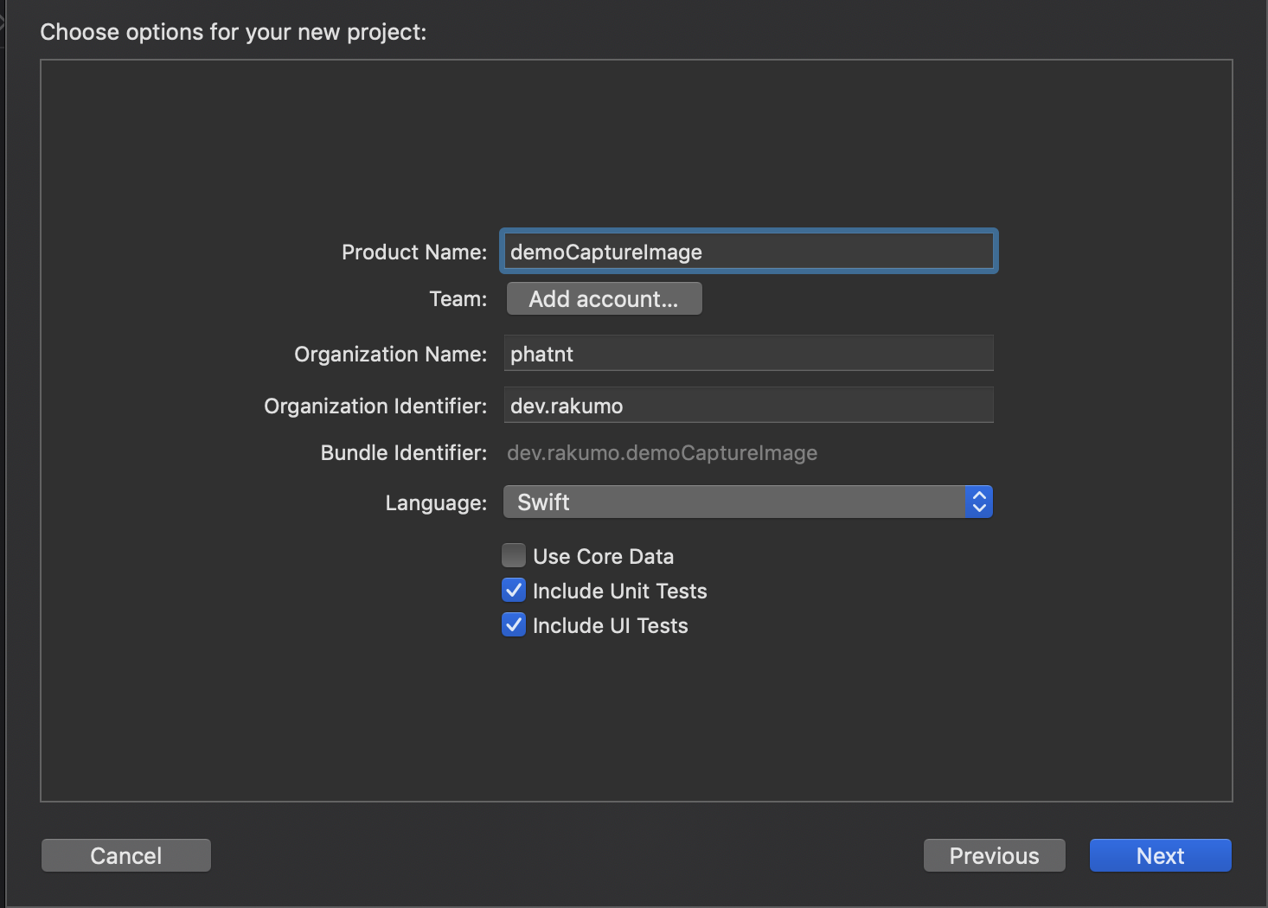

1. In the window appear, choose your location to save your project then click **“Create”.**

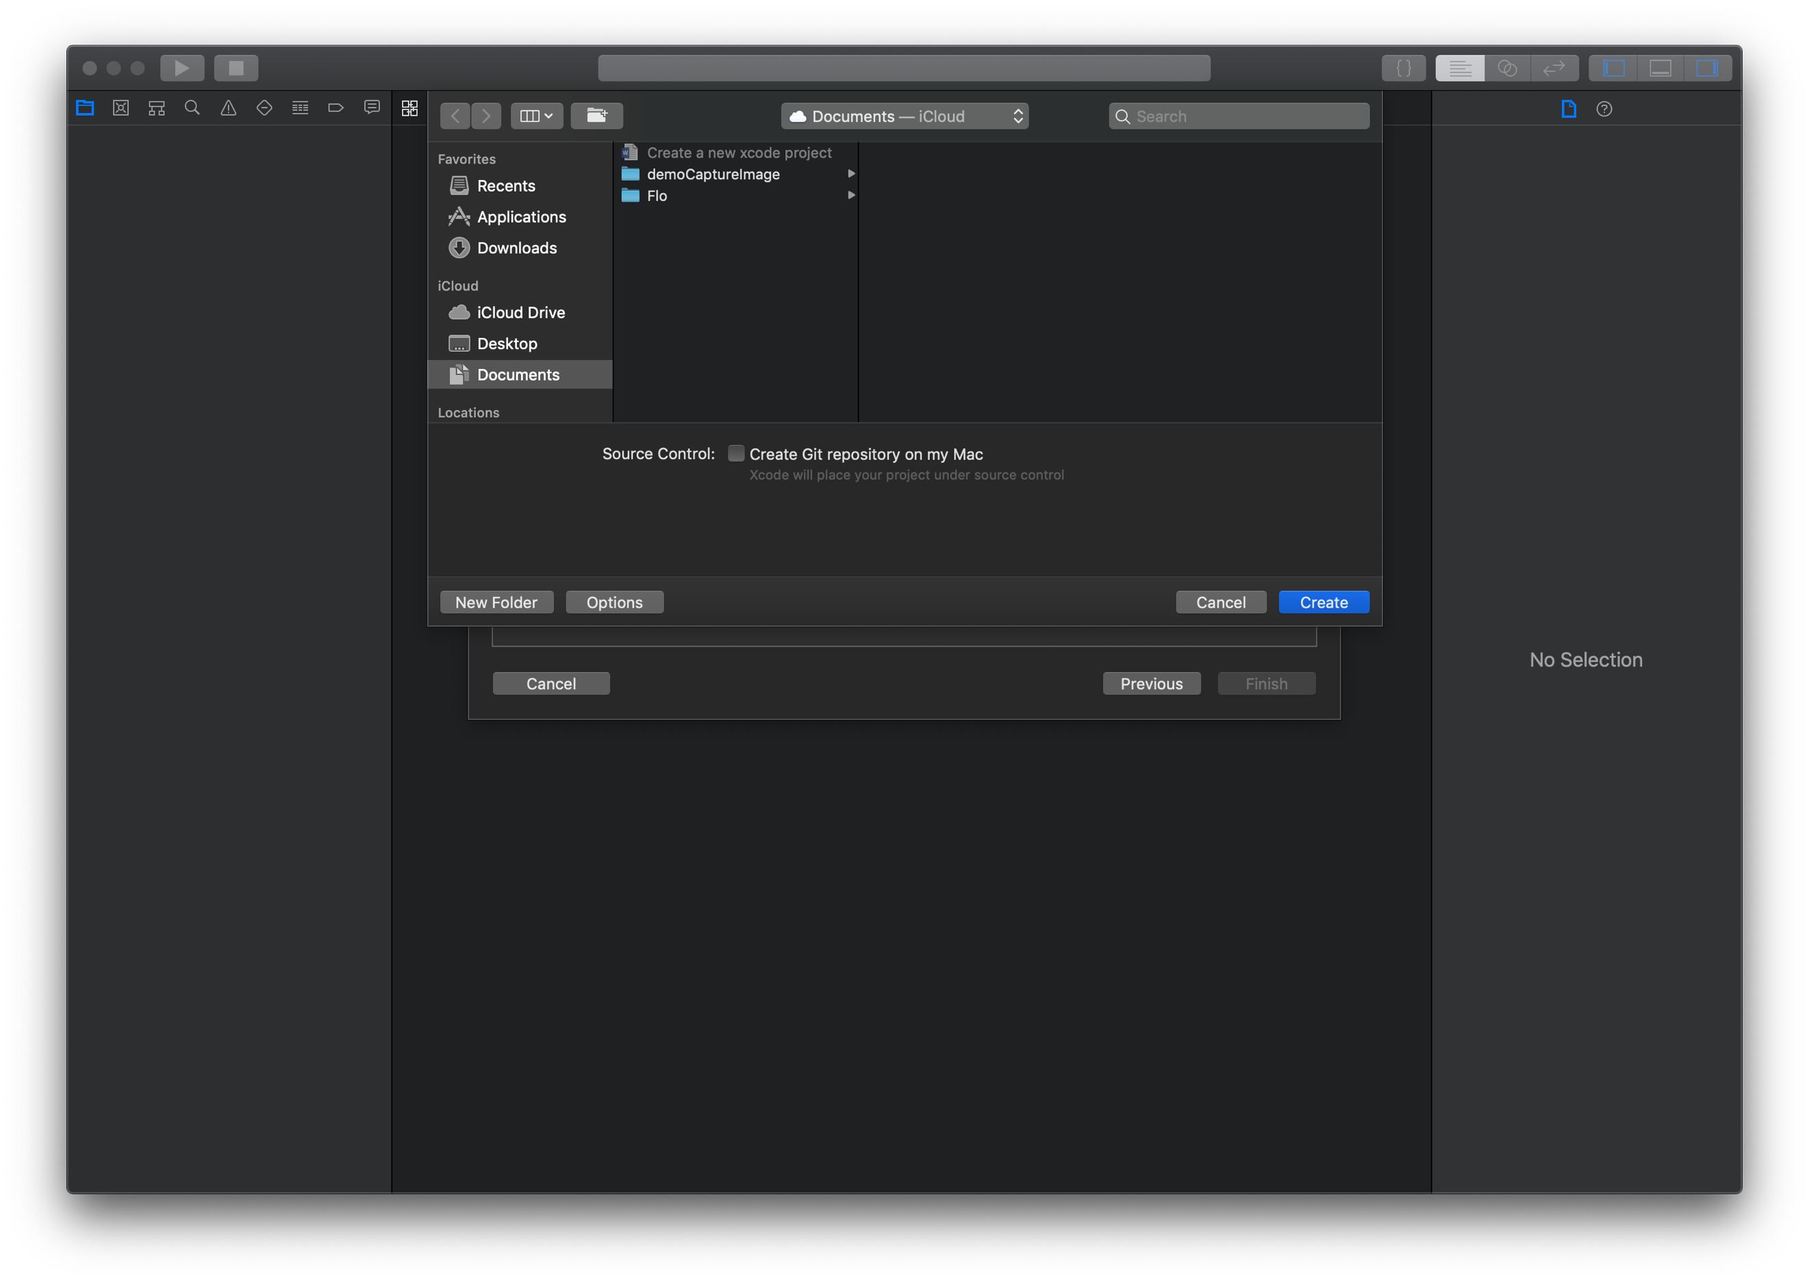

1. That’s all and we can finally set up a new xcode project.